Safe Torque Off for positioning systems PSx 3 with IP65
halstrup-walcher optionally integrates the Safe Torque Off (STO) safety function into its PSx positioning systems 3 series for drives with IP65 and Ethernet-based buses. TÜV-Rheinland certification confirms the safety concept of the hardware.
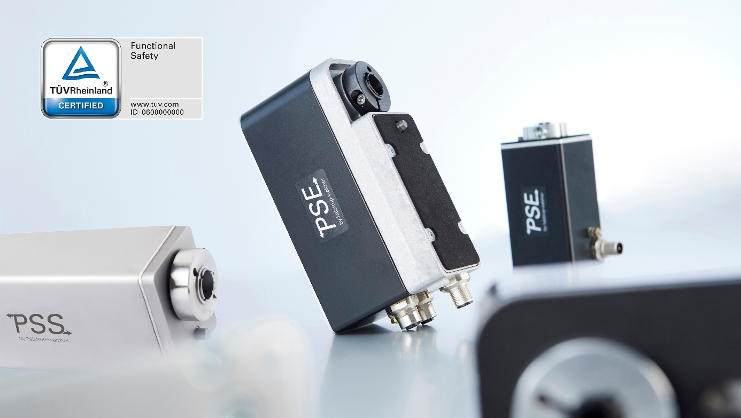
Drives of the positioning systems PSx 3 series with IP65 and new STO option with TÜV certification
The new Safe Tourque Off option of halstrup-walcher's positioning systems is used in applications with high safety requirements, e.g. in adjusting axes of external supply systems of the machines. When the STO function is activated, the motor of the positioning system is switched off. This means that no more torque is generated, the drive coasts to a stop and unintentional start-up of the drive is no longer possible.
Instead of the standard galvanic seperation, the drives with Safe Torque Off function receive a line for the safety shutdown of the positioning system. Activation of the switch-off input by the machine control system is sufficient; an additional safety contact between the control system and the positioning system PSx (actuator) is not necessary. The shortened safety chain minimises the cabling effort and the space required in the control cabinet.
As an option, the control can send regular test pulses (OSSD) to the drive. If the drive does not receive a test pulse, this means that the STO line is defective. The positioning system then sends an error message. Test pulses are required for applications where the reliability of the wiring cannot be ensured in any other way. When suitable cables are used or the cables are laid in a protected manner, such faults can be excluded even without the optional test pulses.
The PSx positioning systems with STO achieve Performance Level c or SIL 1. Since in a hazard analysis the compact drives from halstrup-walcher show no potential for serious or even fatal injuries, this classification is sufficient.

Successful retrofitting with intelligent drives
The positioning systems from halstrup-walcher enable fast and precise changeover of machines. The format adjustment is exactly reproducible, can be controlled for several axes simultaneously at the touch of a button and is also monitored by various parameters. Thanks to an absolute measuring system, the PSx drives position extremely precisely at torques of up to 25 Nm. The integrated interface of all common bus communications enables easy integration into the machine control system.
Note on length: 2504 characters incl. spaces
Press contact
Regina Körner
halstrup-walcher GmbH
Stegener Straße 10
79199 Kirchzarten
Germany
Tel. +49 7661-3963-16
koerner@halstrup-walcher.com
www.halstrup-walcher.com

